Team Precise

1. **Team Name** – Precise  
   **Team Leader’ name** – Deepen Shrestha  
   **Team Leader’ email id** – [deepenshrestha1@gmail.com](mailto:dipeshshrestha0314@gmail.com)
2. **Solution Brief Overview** -
3. Based on the current situation of Covid-19 crisis, our application is developed to meet the following criteria:-
4. Virtual COVID19 test to help the user to predict whether they have to be infected from the corona virus.
5. Provide the details of the basic medical equipment like sanitizers, masks etc available in a store with the feature of purchasing them online.
6. Provide the user to view the latest news regarding the current context of Covid-19.
7. IBM Chatbot assistant for quick response to user queries.
8. Awareness about the preventive measure of the corona virus.
9. In case of emergency, the user can easily contact the police and ambulance through the app.
10. Additionally, the app features entertainment for the user enabling them to play games, watch videos and other various entertainment.
11. Technology Used:

**Tenserflow** for Mobile applications to implement Machine Learning powered app that can VIRTUALLY predict the RISK for the COVID19 through ML Algorithms.

**Datset:** <https://github.com/deepen-stha/CovidInfo/blob/master/corona_data.csv>

**IBM Chatbot** service helped us to add one extra layer of assistant feature to the users. It help addressing an issue to the current COVID19 pandemic. It quickly responds to all the queries of the users

**Google’s Firebase Real Time Database** helped to add all the essentials items to be available to the people at their convenience through an app.

1. **Working Model**

Youtube: <https://www.youtube.com/watch?v=0y5mfz7fxkM&feature=youtu.be>

1. **Solution Description**

Covid-19 Crisis has changed the daily routine of the whole world and created a pandemic among each and every individual around the world. From a small business scale to the top most business organization, the crisis has destroyed the market. And in this type of pandemic, people are facing issues with their daily needs. Understanding the current situation, the problems can be highlighted as below:

1. Crisis on availability of essential products like PPE, Face Mask, Face Shield, Gloves, Sanitizer.
2. Fear among people, even though they are isolated if they are infected from the virus.
3. Small medical store are failing to provide their stock information to the people, resulting in the verge of their downfall.
4. Shortage of goods and medical equipment which is really important in order to survive from the pandemic.
5. In the long term quarantine, the people are partially free from their work and have a lot of time to kill with least indoor activity to participate in. Due to this, the heavy boredom has struck among the people.

Taking above problems in account, this application developed has tried its best to solve them by providing two modes for the user; **medical store mode** and **customer/normal mode**.

The medical store mode is alike the customer/alike mode as discussed above in the Solution Brief but with additional feature as follows:

1. Publishing the stock information to the user.
2. Facilitates the medical personnel to update the stock database as per the quantity of equipment they are having.
3. **Solution Architecture:**

The Architecture has been presented in the form of **WHY**, **WHAT** and **HOW** that clearly describes each and every feature available in our application,

1. Virtual COVID19 Test:

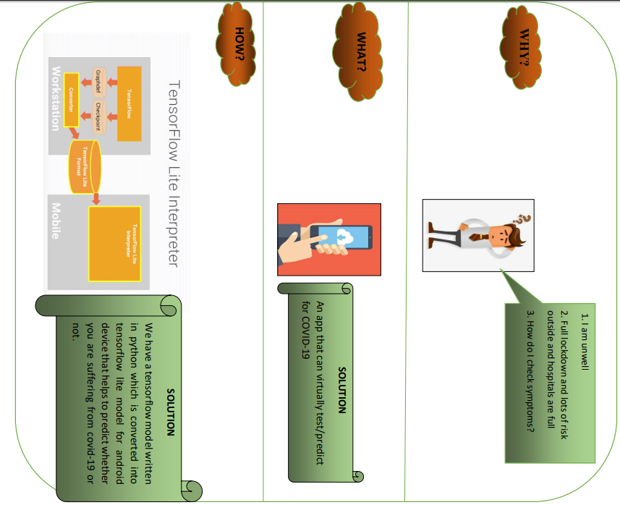

1. Products Availability:

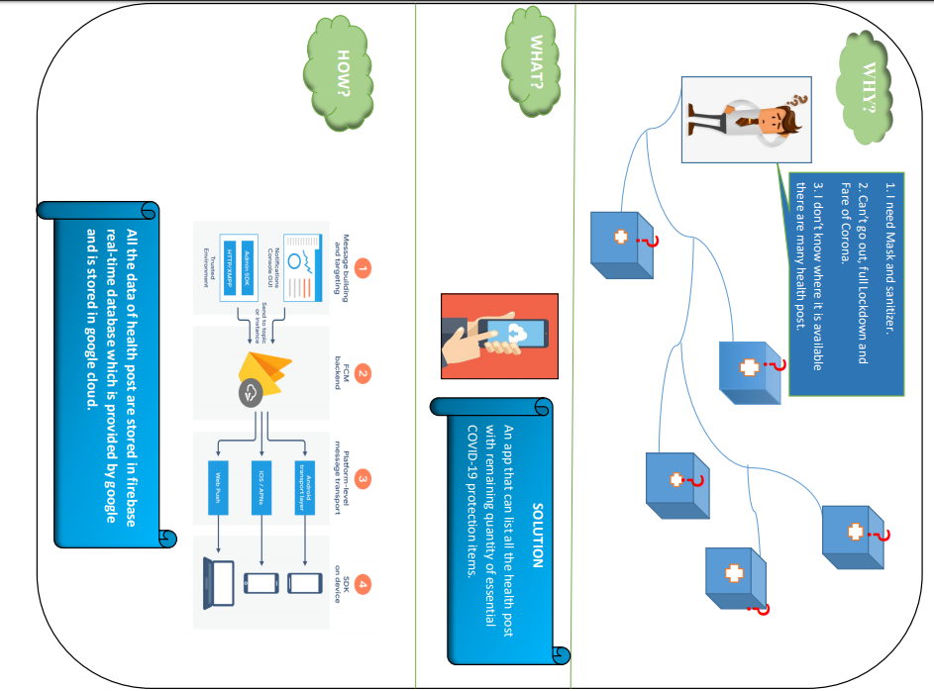

1. IBM Powered Chatbot:

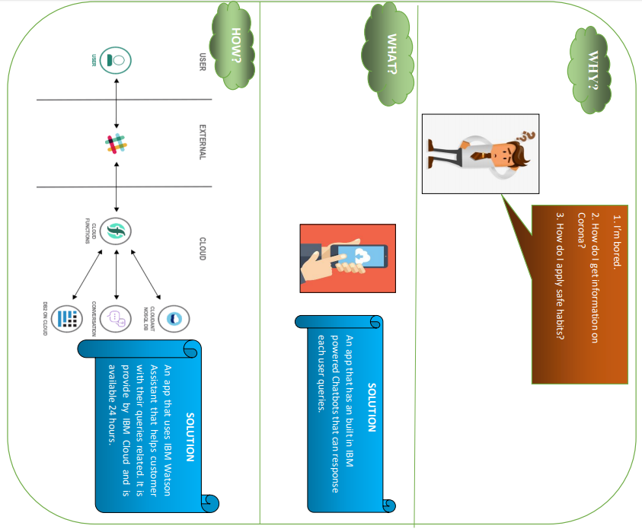

1. Covid Info:

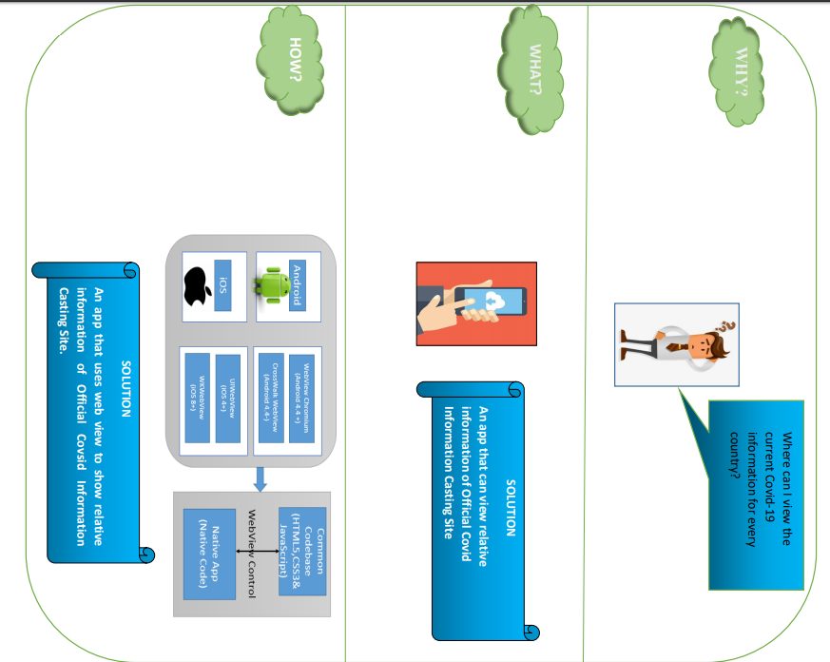

1. Google’s Text to Speech:

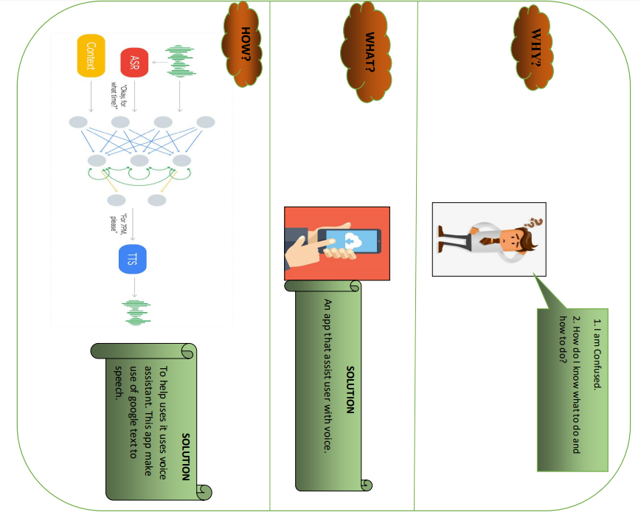

**Technology used**

Precise uses different types of technology to provide the best services. The technology we have using are illustrated below:

1. **Tensorflow**: Machine learning helps the user to predict whether they are infected from the virus or not. The app is using the Tensor Flow implementing the concept of the Multiple Linear Regression and Neural Networking. The concept of deep learning for prediction is thoroughly implemented.
2. **Firebase**: Firebase helps to secure the user account data through the authentication. The app uses real time database to store the user data and stocks from the medical stores.
3. **Text to Speech**: The app is provided with an interesting feature of Text to Speech. This is provided by the Google in which the app interacts with the user through voice.
4. **IBM Cloud Services/Systems**

This application uses IBM Watson Assistant as one of the IBM Cloud Services. IBM Watson Assistant is a question and answer system that provides a dialogue interaction between the conversation system and users. This style of interaction is commonly called as **chatbot.** The IBM Watson Assistant Chat Bot here in our app uses to make user query and to give them the latest information regarding the Covid-19 crisis.